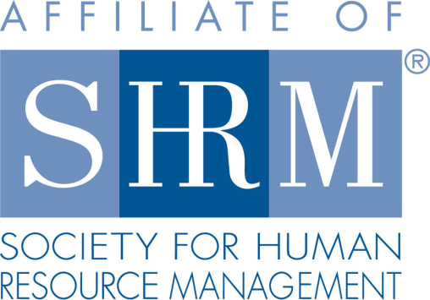
Federal Court Report
Single Use of Racial Slur Can Create Hostile Work Environment
5/10/2022
By Meghan E. O'Kane - Swerdlow Florence Sanchez Swerdlow & Wimmer
A member of Worklaw® Network
The single use of a racial epithet can give rise to a viable claim of a hostile work environment under Title VII of the Civil Rights Act of 1964, according to the 5th U.S. Circuit Court of Appeals. Title VII prohibits discrimination and harassment on the basis of race.
An employee sued his employer, alleging, among other things, that his supervisor called him the N-word in the presence of other workers, thereby creating a hostile work environment. The lower court dismissed the claim, concluding that a single comment was insufficient to support a claim under Title VII.
On appeal, the 5th Circuit reversed the decision, deciding that the employee had stated a viable claim. While acknowledging it had previously found that a single instance involving the use of a racial slur does not, in and of itself, support a hostile work environment claim, the appeals court clarified that the question depends on the totality of the circumstances.
The court went on to explain that the N-word is an especially offensive term and suggested that there is perhaps no single act that could create a hostile work environment quicker than a supervisor's use of a racial epithet in front of subordinates.
By holding that a single incident can give rise to an actionable hostile work environment claim under Title VII, the 5th Circuit joined a growing consensus among federal appellate circuits. The message is clear: One racial slur is one too many.
Woods v. Cantrell, 5th Cir., No. 21-30150 (March 24, 2022).
Takeaway: In many situations, employers are strictly liable for the actions of their supervisors under Title VII. This means that a supervisor's conduct can result in liability for the employer even if the company takes immediate action to address the situation upon learning of the inappropriate behavior. Because of the growing consensus that even a single incident can lead to liability, employers should train their supervisory employees to avoid behavior that can create a hostile work environment, including the use of racial slurs and other offensive language.
Meghan E. O'Kane is an attorney with Swerdlow Florence Sanchez Swerdlow & Wimmer, the Worklaw® Network member firm in Los Angeles.

