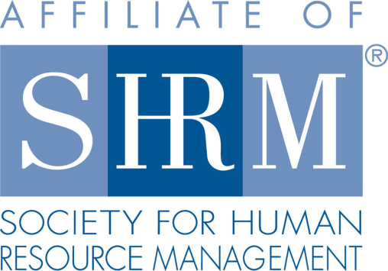
Federal Court Report
Employer Liable for OSHA Citation
2/22/2022
By Kevin L. Kula - Masud Labor Law Group
A member of Worklaw® Network
When a supervisor directed an employee to proceed with excavation operations despite knowing of unsafe working conditions, their employer was vicariously liable for a willful violation of Occupational Safety and Health Administration (OSHA) rules, the 5th U.S. Circuit Court of Appeals decided. The court determined that the supervisor's disregard of safety rules did not constitute the crux of the infraction such that it might relieve the company from liability as unforeseeable supervisor misconduct.
OSHA safety rules prohibit excavations performed without the use of an adequate protective system to prevent cave-ins. Angel Brothers Enterprises, which performs over 1,000 excavations annually, was installing a drainage pipe while using the "benching" prevention method, which involves digging steps at the sides of a trench to prevent it from collapsing.
Once the trench became too close to a road to continue benching, an Angel Brothers safety manager ordered the foreman to begin using a "trench box" instead, which features walls that protect a worker. The foreman deliberately disregarded those instructions, allowing a subordinate to work in the trench without benching or a trench box.
A visiting OSHA compliance officer witnessed Angel Brothers' safety violation and issued a citation. An administrative law judge and OSHA's review commission upheld the citation, issuing a $35,000 penalty.
On appeal, the company did not dispute that its employee had performed work without cave-in protection. Instead, it challenged whether it could be held responsible for its foreman's refusal to follow company policy and instructions.
Typically, an employer is vicariously liable for a supervisor's knowledge of the unsafe conduct of a subordinate. However, in 2006, the 5th Circuit recognized an exception to this standard agency principle. Specifically, the court said an employer is not liable when a supervisor's own unforeseeable misconduct results in a citation. Angel Brothers claimed this exception applied, arguing that its foreman's act of allowing a worker to work in an unprotected trench was the misconduct that resulted in the citation.
The 5th Circuit rejected this defense, concluding that the foreman himself did not engage in the unsafe work.
"Authorizing another's violation is not the same as committing the violation oneself," the court said.
The court also recognized that Angel Brothers' theory, if accepted, would "upend agency principles" because it would limit employer liability to only situations involving a supervisor's passive involvement in a safety violation. In other words, an employer would be liable only when a supervisor learns of a violation by chance, as opposed to when a supervisor authorizes unsafe work.
The court also rejected Angel Brothers' argument that it was not liable because the violation occurred due to unpreventable misconduct. The company had been cited for prior trench safety violations and failed to demonstrate that it consistently enforced its safety rules. The court found only two documented cases of employee discipline related to safety violations, both of which only came after OSHA inspectors observed the violations. Based on this evidence, the court concluded that Angel Brothers had failed to prove it enforced its safety rules when violations were discovered, an essential element of the unpreventable misconduct defense.
Angel Bros. Enters. Ltd. v. Walsh, 5th Cir., No. 20-60849 (Dec. 1, 2021).
Professional Pointer: This case serves as a reminder of the legal risks associated with supervisors who ignore safety rules, as well as the importance of safety rule enforcement. Generally, an employer cannot avoid liability for safety violations even if it can show its supervisor failed to follow safety rules or instructions.
Kevin L. Kula is an attorney with Masud Labor Law Group, the Worklaw® Network member firm in Saginaw, Mich.

